Project Design Phase-II
Technology Stack (Architecture & Stack)

Date | 03 October 2026
Team ID | SWTID-2026-8647
Project Name | Implement Client Script & UI Policy (Incident)
Maximum Marks | 4 Marks

Technical Architecture:
The Deliverable shall include the architectural diagram as below and the information as per the table1 & table 2
Example: ServiceNow Incident form control architecture
Reference: https://developer.servicenow.com/
Guidelines:
Include all the processes (As an application logic / Technology Block)
Provide infrastructural demarcation (Local / Cloud)
Indicate external interfaces (third party API’s etc.)
Indicate Data Storage components / services
Indicate interface to machine learning models (if applicable)
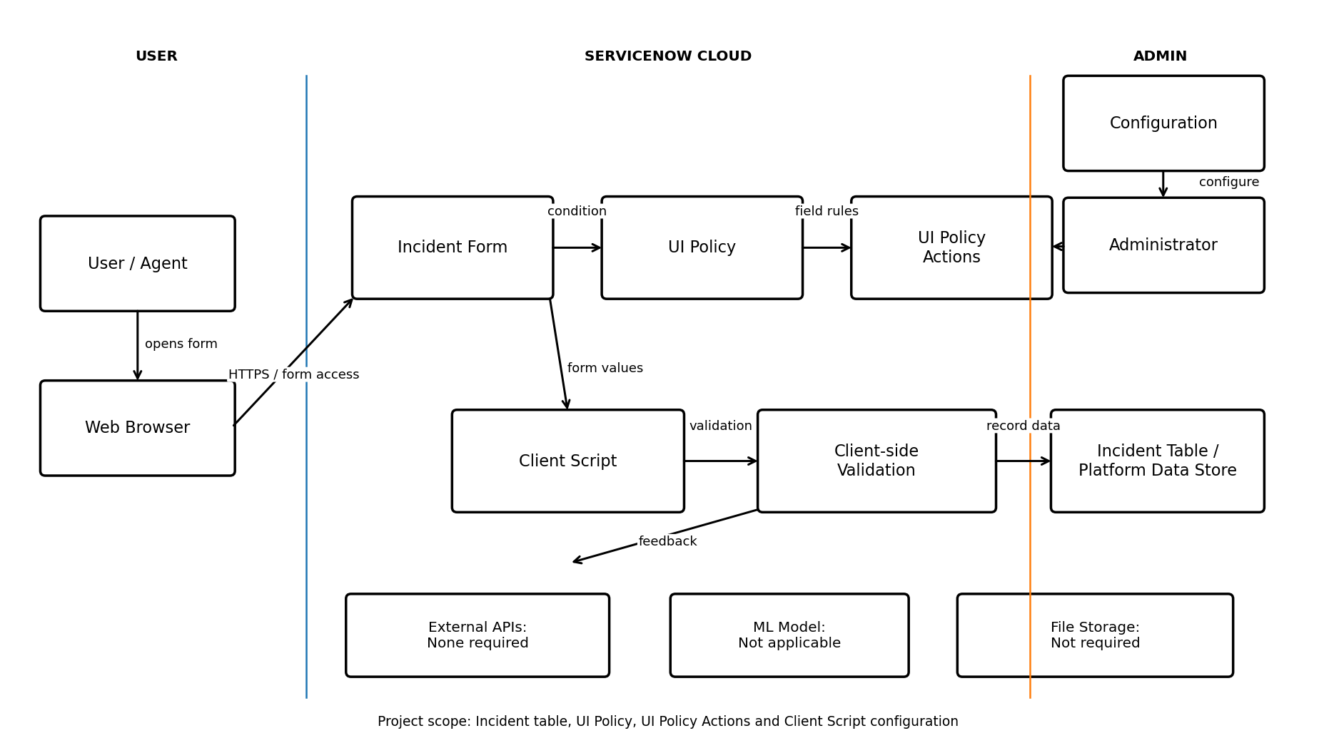

Table-1 : Components & Technologies:
S.No | Component | Description | Technology
1 | User Interface | User interaction with the Incident form. | ServiceNow Incident form / Web browser
2 | Application Logic-1 | Controls fields using configured conditions. | ServiceNow UI Policy
3 | Application Logic-2 | Applies mandatory, visible, and read-only settings. | ServiceNow UI Policy Actions
4 | Application Logic-3 | Supports client-side form behavior and validation. | ServiceNow Client Script / GlideForm API
5 | Database | Stores Incident records and field values. | ServiceNow Incident table / platform data store
6 | Cloud Database | Managed data storage within the ServiceNow platform. | ServiceNow platform-managed cloud data storage
7 | File Storage | No separate file storage is required for the core project. | Not required; ServiceNow platform storage if attachments are used
8 | External API-1 | No external API is required. | Not applicable
9 | External API-2 | No second external API is required. | Not applicable
10 | Machine Learning Model | No machine learning model is used. | Not applicable
11 | Infrastructure (Server / Cloud) | Runs in the ServiceNow cloud instance; local use is via a web browser. | Cloud: ServiceNow instance; Local: Web browser

Table-2: Application Characteristics:
S.No | Characteristics | Description | Technology
1 | Open-Source Frameworks | No additional open-source framework is required. | ServiceNow configuration
2 | Security Implementations | Use authenticated access, roles, and table/field access controls. | ServiceNow roles and ACLs; platform controls
3 | Scalable Architecture | Managed cloud platform; no separate application servers are required. | ServiceNow SaaS / cloud platform
4 | Availability | Access is through the ServiceNow cloud instance; no project load balancer is configured. | ServiceNow cloud platform
5 | Performance | Uses lightweight form controls; no external API or ML calls are required in the core flow. | ServiceNow client-side form behavior

References:
https://developer.servicenow.com/print_page.do?category=learning-module&identifier=app_store_learnv2_scripting_yokohama_client_scripts_vs_ui_policies%2Cnew_to_servicenow&module=learning%2Bplan&release=yokohama
https://developer.servicenow.com/print_page.do?category=learning-module&identifier=app_store_learnv2_scripting_yokohama_client_scripts_vs_ui_policies%2Cnew_to_servicenow&module=learning%2Bplan&release=yokohama
https://developer.servicenow.com/print_page.do?category=learning-module&identifier=app_store_learnv2_scripting_washingtondc_client_side_scripting%2Capp_store_learnv2_scripting_washingtondc_test_your_client_side_scripting_knowledge&module=course&release=washingtondc
https://developer.servicenow.com/print_page.do?category=null&identifier=clientListPage&module=api&release=yokohama
https://www.servicenow.com/in/products/incident-management.html

